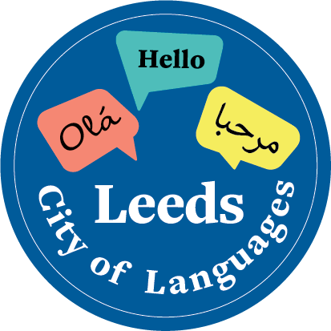
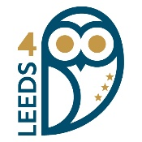
Many Languages, One Leeds
170 languages. One city. Thousands of voices.

Project Registration Form
Schools, settings and youth groups wishing to take part should complete this form and return it to leedscityoflanguages@leeds.ac.uk. Once registered, we will confirm arrangements for receiving your cardboard tiles and returning completed artwork.
Name of school / setting / group
Lead contact name
Email and telephone number
Address (for tiles to be sent)
Website or social media of the setting (optional)
Age or year group(s) taking part
Approximate number of young people taking part
Number of cardboard tiles required
Languages represented or likely to be represented. An approximate list is fine at registration stage.
Any access, delivery or practical requirements we should know about?

Return this registration form to: leedscityoflanguages@leeds.ac.uk
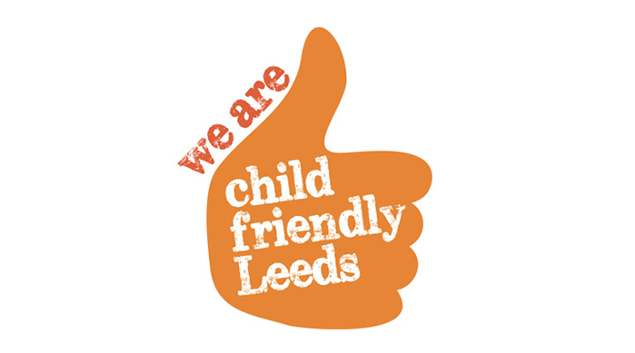
Registration deadline: 19th October 2026

